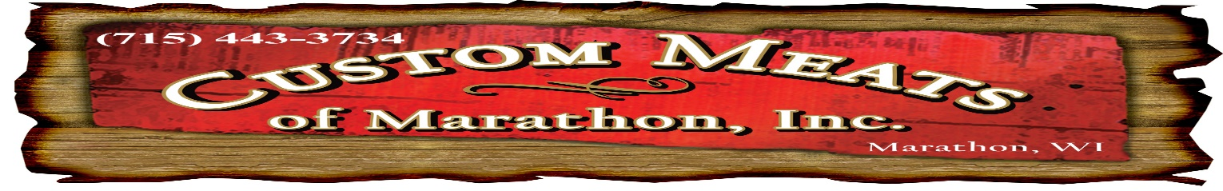
2020 VENISON
PROCESSING FEES
DEER(SKIN, CUT, GRIND, WRAP, FREEZE) $135.00
DEER (caping for mounting-if requested) $35.00
Cutting off horns or head (if requested) $5.00
Grinding & packaging boneless trim that you bring in $1.00/lb
*We require a $50.00 non-refundable deposit at drop off. Any orders not picked-up within 60 days will be donated to the food pantry. Your deposit will not be refunded.
Sausage Menu
Recipe Ratio of Venison to Pork Price per lb (includes vac-seal)
1 to 1 Summer Sausage-Regular $3.99
1 to 1 Summer Sausage-Garlic w/ Mustard Seed $3.99
NEW 1 to 1 Summer Sausage with Cheddar Cheese $4.49
1 to 1 Sticks-Cracked Pepper and Garlic (approx. 30% shrink) $4.49
1 to 1 Sticks-Sweet Maple Bacon (approx. 30% shrink) $4.49
1 to 1 Sticks-Snack (approx. 30% shrink) $4.49
1 to 1 Sticks-Spicy (approx. 30% shrink) $4.49
1 to 1 Sticks-BBQ (approx. 30% shrink) $4.49
NEW 1 to 1 Sticks-Cracked Pepper and Garlic with Cheddar Cheese (approx. 30% shrink) $4.79
1 to 1 Traditional Weiners-Natural Casing (approx. 10% shrink) $3.99
1 to 1 Kielbasa (approx. 10% shrink) $3.89
1 to 1 Pit Smoked Kielbasa (slow smoked with hickory hardwood, approx. 10% shrink) $4.39
1 to 1 Smoked Cheddarwurst (approx. 10% shrink) $4.39
1 to 1 Venison Bacon (approx. 15% shrink) $3.99
1 to 1 Breakfast Links $3.89
1 to 1 Bulk Breakfast Sausage (1# tubes) $2.99
1 to 1 Brats (Award Winning German Flavor) $3.89
1 to 1 Ring Bologna $3.89
*We require a 10 lb minimum of your venison for each item you choose from our sausage menu
*Price subject to change without notice
THANK YOU FOR YOUR BUSINESS
Venison and CWD: We provide a custom processing service for your game animals and take the highest precautions in safety and sanitation of our facilities and equipment. We cannot guarantee that any animal drought in for processing does or does not have CWD. That testing may be done by game agency officials or by sportsmen. but cannot be done in this facility We cannot assume responsibility for animal testing or failure to test for CWD
Custom Meats viewpoint on CWD is based upon the position of the Dept. of Agriculture that there is no evidence that CWD is transmittable to humans. These views are also shared by the World Health Organization and the Center of Disease Control
Although there is no scientific evidence, Custom Meats would encourage all hunters to follow the guidelines set by the Dept. of Agriculture on cutting your wild game.

